Exception Handling in Java

The Exception Handling in Java is one of the powerful mechanism to handle the runtime errors so that normal flow of the application can be maintained.

What is Exception in Java
Dictionary Meaning: Exception is an abnormal condition.
An exception (or exceptional event) is a problem that arises during the execution of a program. When an Exception occurs the normal flow of the program is disrupted and the program/Application terminates abnormally, which is not recommended, therefore, these exceptions are to be handled.

What is Exception Handling
Exception Handling is a mechanism to handle runtime errors such as
ClassNotFoundException, IOException, SQLException, RemoteException, etc.

Hierarchy of Java Exception classes

The java.lang.Throwable class is the root class of Java Exception hierarchy which is inherited by two subclasses: Exception and Error. A hierarchy of Java Exception classes are given below: 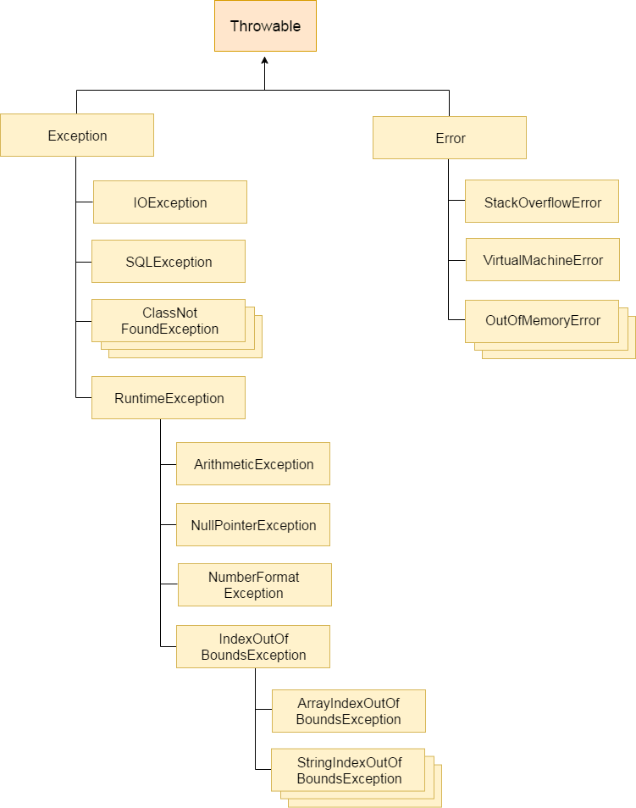

Types of Java Exceptions
There are mainly two types of exceptions: checked and unchecked. Here, an error is considered as the unchecked exception. According to Oracle, there are three types of exceptions:
- Checked Exception
- Unchecked Exception
- Error

Difference between Checked and Unchecked Exceptions

1) Checked Exception
The classes which directly inherit Throwable class except RuntimeException and Error are known as checked exceptions e.g. IOException, SQLException etc. Checked exceptions are checked at compile-time.

2) Unchecked Exception
The classes which inherit RuntimeException are known as unchecked exceptions e.g. ArithmeticException, NullPointerException, ArrayIndexOutOfBoundsException etc. Unchecked exceptions are not checked at compile-time, but they are checked at runtime.

3) Error
Error is irrecoverable e.g. OutOfMemoryError, VirtualMachineError, AssertionError etc.

Java Exception Keywords

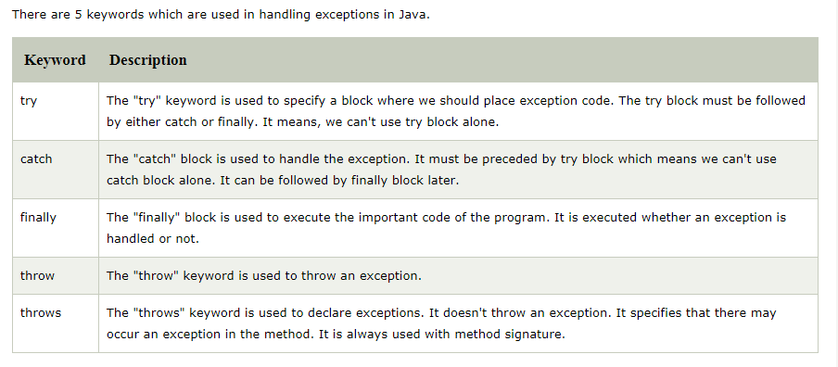

Summary of exception Handling

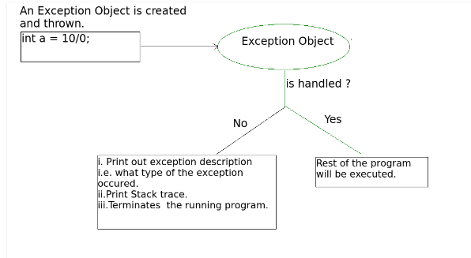

Java try-catch block

Java try block
Java try block is used to enclose the code that might throw an exception. It must be used within the method.
If an exception occurs at the particular statement of try block, the rest of the block code will not execute. So, it is recommended not to keep the code in try block that will not throw an exception.
Java try block must be followed by either catch or finally block.

Syntax of Java try-catch

try
{
//code that may throw an exception
}
catch(Exception_class_Name ref)
{
//exception handling code
}

Syntax of try-finally block

try
{
//code that may throw an exception
}
Finally
{
}

Java catch block
Java catch block is used to handle the Exception by declaring the type of exception within the parameter. The declared exception must be the parent class exception ( i.e., Exception) or the generated exception type. However, the good approach is to declare the generated type of exception.
The catch block must be used after the try block only. You can use multiple catch block with a single try block.

Java finally block
Java finally block is a block that is used to execute important code such as closing connection, stream etc.
Java finally block is always executed whether exception is handled or not.
Java finally block follows try or catch block.

Flowchart of finally block execution

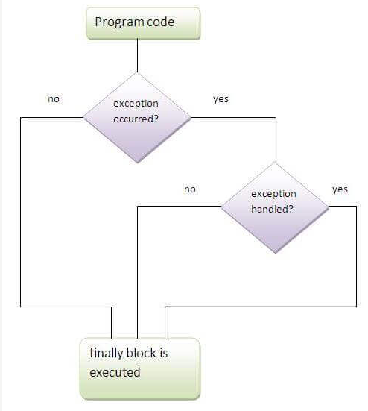

Why use java finally
- Finally block in java can be used to put "cleanup" code such as closing a file, closing connection etc.

Example without exception handling

public class Main
{
public static void main(String args[])
{

int data=100/0;
System.out.println("rest of the code...");
}
}

Output:

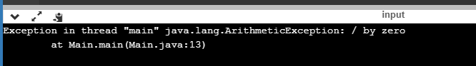

This exception can be handled using try – catch block

public class Main
{
public static void main(String args[])
{
try
{
//code that may raise exception
int data=100/0;
}
catch(ArithmeticException e)
{
System.out.println(e);
}
//rest code of the program
System.out.println("rest of the code...");
}
}

Output:
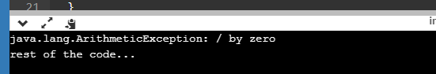

Example with try-catch-finally block

public class Main
{
public static void main(String args[])
{
try
{
int data=100/0;
}
catch(ArithmeticException e)
{
System.out.println(e);
}
finally
{
System.out.println("finally block is executed");
}
System.out.println("rest of the code...");
}
}

Output:

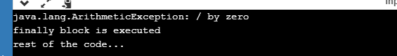

Common Scenarios of Java Exceptions
There are given some scenarios where unchecked exceptions may occur. They are as follows:

1) A scenario where ArithmeticException occurs
If we divide any number by zero, there occurs an ArithmeticException.
- int a=50/0;//ArithmeticException

2) A scenario where NullPointerException occurs
If we have a null value in any variable, performing any operation on the variable throws a NullPointerException.
- String s=null;
- System.out.println(s.length());//NullPointerException

3) A scenario where NumberFormatException occurs
The wrong formatting of any value may occur NumberFormatException. Suppose I have a string variable that has characters, converting this variable into digit will occur NumberFormatException.
- String s="abc";
- int i=Integer.parseInt(s);//NumberFormatException

4) A scenario where ArrayIndexOutOfBoundsException occurs
If you are inserting any value in the wrong index, it would result in ArrayIndexOutOfBoundsException as shown below:
- int a[]=new int[5];
- a[10]=50; //ArrayIndexOutOfBoundsException

5) A scenario where StringIndexOutOfBoundsException occurs

String str="OOPM";
System.out.println(str.length());;
char c = str.charAt(5);

Java Multi-catch block
A try block can be followed by one or more catch blocks. Each catch block must contain a different exception handler. So, if you have to perform different tasks at the occurrence of different exceptions, use java multi-catch block.

Points to remember
- At a time only one exception occurs and at a time only one catch block is executed.
- All catch blocks must be ordered from most specific to most general, i.e. catch for ArithmeticException must come before catch for Exception.

Example 1
Let's see a simple example of java multi-catch block.
public class MultipleCatchBlock1 {

public static void main(String[] args) {

try{
int a[]=new int[5];
a[5]=30/0;
}
catch(ArithmeticException e)
{
System.out.println("Arithmetic Exception occurs");
}
catch(ArrayIndexOutOfBoundsException e)
{
System.out.println("ArrayIndexOutOfBounds Exception occurs");
}
catch(Exception e)
{
System.out.println("Parent Exception occurs");
}
System.out.println("rest of the code");
}
}

Output

Arithmetic Exception occurs
rest of the code

Example 2
public class MultipleCatchBlock2 {

public static void main(String[] args) {

try{
int a[]=new int[5];

System.out.println(a[10]);
}
catch(ArithmeticException e)
{
System.out.println("Arithmetic Exception occurs");
}
catch(ArrayIndexOutOfBoundsException e)
{
System.out.println("ArrayIndexOutOfBounds Exception occurs");
}
catch(Exception e)
{
System.out.println("Parent Exception occurs");
}
System.out.println("rest of the code");
}
}
Output:
ArrayIndexOutOfBounds Exception occurs
rest of the code

Example 3
In this example, try block contains two exceptions. But at a time only one exception occurs and its corresponding catch block is invoked.
public class MultipleCatchBlock3 {

public static void main(String[] args) {

try{
int a[]=new int[5];
a[5]=30/0; //arithmeticexception
System.out.println(a[10]);//arrayindexoutofbound
}
catch(ArithmeticException e)
{
System.out.println("Arithmetic Exception occurs");
}
catch(ArrayIndexOutOfBoundsException e)
{
System.out.println("ArrayIndexOutOfBounds Exception occurs");
}
catch(Exception e)
{
System.out.println("Parent Exception occurs");
}
System.out.println("rest of the code");
}
}

Output:
Arithmetic Exception occurs
rest of the code

Solution to this problem is use of multiple try-catch blocks

public class Main
{
public static void main(String[] args)
{
int a[]=new int[5];
try
{
a[5]=30/0;
}
catch(ArithmeticException e)
{
System.out.println("Arithmetic Exception occurs");
}
try
{
System.out.println(a[10]);
}
catch(ArrayIndexOutOfBoundsException e)
{
System.out.println("ArrayIndexOutOfBounds Exception occurs");
}
catch(Exception e)
{
System.out.println("Parent Exception occurs");
}
System.out.println("rest of the code");
}
}
Output
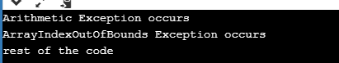

Example 4
In this example, we generate NullPointerException, but didn't provide the corresponding exception type. In such case, the catch block containing the parent exception class Exception will invoked.
public class MultipleCatchBlock4 {

public static void main(String[] args) {

try{
String s=;
System.out.println(s.length());
}
catch(ArithmeticException e)
{
System.out.println("Arithmetic Exception occurs");
}
catch(ArrayIndexOutOfBoundsException e)
{
System.out.println("ArrayIndexOutOfBounds Exception occurs");
}
catch(Exception e)
{
System.out.println("Parent Exception occurs");
}
System.out.println("rest of the code");
}
}
Output:
Parent Exception occurs
rest of the code

Java Nested try block
The try block within a try block is known as nested try block in java.

Why use nested try block
Sometimes a situation may arise where a part of a block may cause one error and the entire block itself may cause another error. In such cases, exception handlers have to be nested.

public class Main
{
public static void main(String[] args)
{
int a[]=new int[5];
try
{
try
{
a[5]=30/0;
}
catch(ArithmeticException e)
{
System.out.println("Arithmetic Exception occurs");
}
try
{
System.out.println(a[10]);
}
catch(ArrayIndexOutOfBoundsException e)
{
System.out.println("ArrayIndexOutOfBounds Exception occurs");
}
}
catch(Exception e)
{
System.out.println("Parent Exception occurs");
}
System.out.println("rest of the code");
}
}
Ouput:

Java program to handle many exceptions with single try-catch block
public class Main
{
public static void main (String args[ ] )
{
Scanner scan = new Scanner(System.in);
int i = scan.nextInt();
int j;
try
{
switch (i)
{
case 0 :
int zero = 0;
j = 92/ zero;
break;
case 1 :
int b[ ] = null;
j = b[0] ;
break;
default:
System.out.print("No exception");
}
}
catch(Exception e)
{
// e.printStackTrace();
//System.out.println(e);
System.out.print(e.toString()); }}}
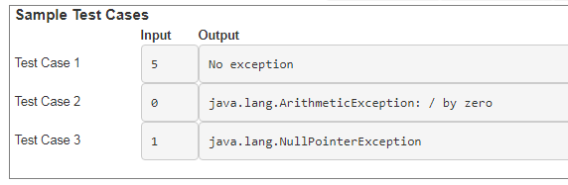
This is the output if we use following syntax for exception handling:
catch(Exception e)
{
e.printStackTrace();
System.out.println(e);}
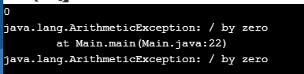
This is the output if we use following syntax for exception handling:
catch(Exception e)
{
System.out.println(e.getMessage());
}



